Subscribers Galore : Exploring World’s Top Youtube Channels

☺ YouTube is an [online video sharing](https://en.wikipedia.org/wiki/Online_video_platform) and [social media](https://en.wikipedia.org/wiki/Social_media) platform headquartered in [San Bruno, California](https://en.wikipedia.org/wiki/San_Bruno,_California), [United States](https://en.wikipedia.org/wiki/United_States). Accessible worldwide, it was launched on February 14, 2005, by [Steve Chen](https://en.wikipedia.org/wiki/Steve_Chen), [Chad Hurley](https://en.wikipedia.org/wiki/Chad_Hurley), and [Jawed Karim](https://en.wikipedia.org/wiki/Jawed_Karim). It is owned by [Google](https://en.wikipedia.org/wiki/Google) and is the [second most visited](https://en.wikipedia.org/wiki/List_of_most_visited_websites) website in the world, after [Google Search](https://en.wikipedia.org/wiki/Google_Search). YouTube has more than 2.5 billion monthly users, who collectively watch more than one billion hours of videos every day. As of May 2019, videos were being uploaded to the platform at a rate of more than 500 hours of [content](https://en.wikipedia.org/wiki/Content_(media)) per minute.

☺ A subscriber to a channel on the video-sharing YouTube is a user who has chosen to receive the channel's content by clicking on that channel's "Subscribe" button, and each user's subscription feed consists of videos published by channels to which the user is subscribed. The ability to subscribe to users was introduced in October 2005. YouTube began publishing a list of its most-subscribed channels in April 2006. An early archive of the list dates to May 2006.

☺ The following table lists the 50 most-subscribed YouTube channels, as well as the primary language and content category of each channel. The channels are ordered by number of subscribers; those whose displayed subscriber counts are identical are listed so that the channel whose current growth rate indicates that its displayed subscriber count will exceed that of the other channel is listed first. Automatically generated channels that lack their own videos (such as Music and News) and channels that have been made effectively obsolete as a result of the transferal of their content (such as Justin Bieber VEVO and Taylor Swift VEVO) are excluded.

☺ As of February 2023, 21 of the 50 channels listed primarily produce content in English while 16 primarily produce content in Hindi. All 50 of the channels have surpassed 40 million subscribers, 39 of them have surpassed 50 million subscribers, 23 of them have surpassed 60 million subscribers, 16 of them have surpassed 70 million subscribers, 12 of them have surpassed 80 million subscribers, 10 of them have surpassed 90 million and 7 of them have surpassed 100 million subscribers. Only 1 channel (T-Series) has surpassed 200 million subscribers.

Project Flow:

To accomplish this, we have to complete all the activities listed below,

● **Define Problem / Problem Understanding**

o Specify the business problem

o Business requirements

o Literature Survey

● **Data Collection & Extraction**

o Collect the dataset

o Connect Dataset with Tableau

● **Data Preparation**

o Prepare the Data for Visualization

● **Data Visualizations**

o No of Unique Visualizations

● **Dashboard**

o Responsive and Design of Dashboard

● **Story**

o No of Scenes of Story

● **Performance Testing**

o Utilization of Data Filters

o No of Visualizations/ Graphs

● **Publishing**

o Publishing Dashboard & Story to Tableau Public

**● Project Demonstration & Documentation**

o Record explanation Video for project end to end solution

o Project Documentation-Step by step project development procedure.

**Problem / Problem Understanding:**

**☺ Specify the business problem:-**

YouTube has become a source of entertainment and fun for people of all ages in just a decade. Some of the world's biggest brands already have their own YouTube channel, like Google, BMW, Disney and Lego. But big brands are not the only ones capitalizing on YouTube as a promotional venue. Companies of all sizes and types are embracing YouTube to deliver their messages and strengthen their sales pitch.

There is no denying that YouTube presents a huge opportunity to reach and engage with diverse audiences, but only when done right. Here are some of the biggest challenges that marketers face on the platform.

*☺* ***Business requirements Channel Information:-***

*Each YouTube channel should have a dedicated page or profile that displays essential information, including the channel name, description, subscriber count, video views, upload frequency, and engagement metrics.*

*Subscription Management: Users should have the ability to subscribe to their favorite YouTube channels within the platform, allowing them to receive notifications about new uploads and updates from those channels.*

*Analytics and Insights: The platform should provide analytics and insights to track user engagement, popular channels, and trending content. This data can be used to improve content curation, personalize recommendations, and enhance the overall user experience.*

***☺ Literature Survey:-***

YouTube is becoming a major resource for sharing and consuming video content. It is gaining immense popularity and support from viewer community due to its comprehensive repository of videos. Also, it supports diversity by having different facets such as modals, languages, domains and cultures. For a YouTube content developer or a YouTuber with various notable channels this is a profession with a lot of monetary potential. The younger generations are recently shifting to YouTube and other OTT platforms, away from the traditional television.

Data Collection & Extraction:

Data collection is the process of gathering and measuring information on variables of interest, in an established systematic fashion that enables one to answer stated research questions, test hypotheses, and evaluate outcomes and generate insights from the data.

**Collect the dataset:**

The Link to download dataset:-

<https://www.kaggle.com/datasets/rajkumarpandey02/list-of-most-subscribed-youtube-channels-in-world>

**Understand the data:**

*Data contains all the meta information regarding the columns described in the CSV files. We have provided csv file. Column Description for Youtube_Channels.csv:*

*●* **(17) Countries:** *\* India, United States, Sweden, Ukraine, Russia, South Korea,Cyprus[a], Canada, Brazil, Argentina, Romania, United Kingdom, Chile,Mexico, El Salvador, United States (Puerto Rico), Belarus.*

*●* **(8) Categories:** *Music, Education, Entertainment, Games, Sports, Film, How-to,News.*

*●* **(7) Primary Languages:** *English, Hindi, Spanish, Korean, Portuguese,Russian,Bhojpuri.*

**● (49)Name:**

*● T-Series*

*● Cocomelon*

*● Sony Entertainment*

*Television India*

*● MrBeast*

*● PewDiePie*

*● Kids Diana Show*

*● Like Nastya*

*● Vlad and Niki*

*● WWE*

*● Zee Music Company*

*● Blackpink*

*● Goldmines*

*● 5-Minute Crafts*

*● Sony SAB*

*● BangtanTV*

*● Justin Bieber*

*● Hybe Labels*

*● Canal KondZilla*

*● Zee TV*

*● Pinkfong*

*● Shemaroo Entertainment*

*● ChuChu TV*

*● Colors TV*

*● Dude Perfect*

*● Movieclips*

*● T-Series Bhakti Sagar*

*● Tips Industries*

*● Wave Music*

*● Marshmello*

*● Sony Music India*

*● El Reino Infantil*

*● Aaj Tak*

*● Eminem*

*● LooLoo Kids*

*● Ed Sheeran*

*● Yash Raj Films*

*● Ariana Grande*

*● Taylor Swift*

*● BillionSurpriseToys*

*● Infobells*

*● JuegaGerman*

*● Billie Eilish*

*● Badabun*

*● Fernanfloo*

*● Bad Bunny*

*● SonyMusicIndiaVEVO*

*● Shemaroo*

*● Get Movies*

*● Felipe Neto*

*● A4*

**Connect Dataset with Tableau:-**

*Explanation video link:*

## https://drive.google.com/file/d/1iilFRgZFKWrwQAwZPzYPOCq6YRACD7uK/view?usp =sharing

Data Preparation

Prepare the Data for Visualization Preparing the data for visualization involves cleaning the data to remove irrelevant or missing data, transforming the data into a format that can be easily visualized, exploring the data to identify patterns and trends, filtering the data to focus on specific subsets of data, preparing the data for visualization software, and ensuring the data is accurate and complete. This process helps to make the data easily understandable and ready for creating visualizations to gain insights into our analysis.

Data Visualization

Data visualization is the process of creating graphical representations of data in order to help people understand and explore the information. The goal of data visualization is to make complex data sets more accessible, intuitive, and easier to interpret. By using visual elements such as charts, graphs, and maps, data visualizations can help people quickly identify patterns, trends, and outliers in the data.

**No of Unique Visualizations:-**

The number of unique visualizations that can be created with a given dataset. Some common types of visualizations that can be used to analyze the performance and efficiency of project include bar charts, line charts, heat maps, scatter plots, pie charts, Maps etc. These visualizations can be used to compare performance, track changes over time, show distribution, and relationships between variables.

**Rank wish Channel:-**

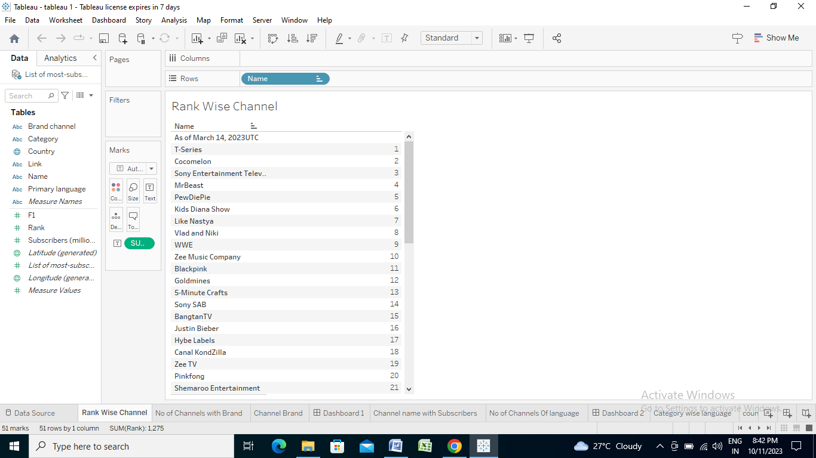

**No of Channels with Brand:-**

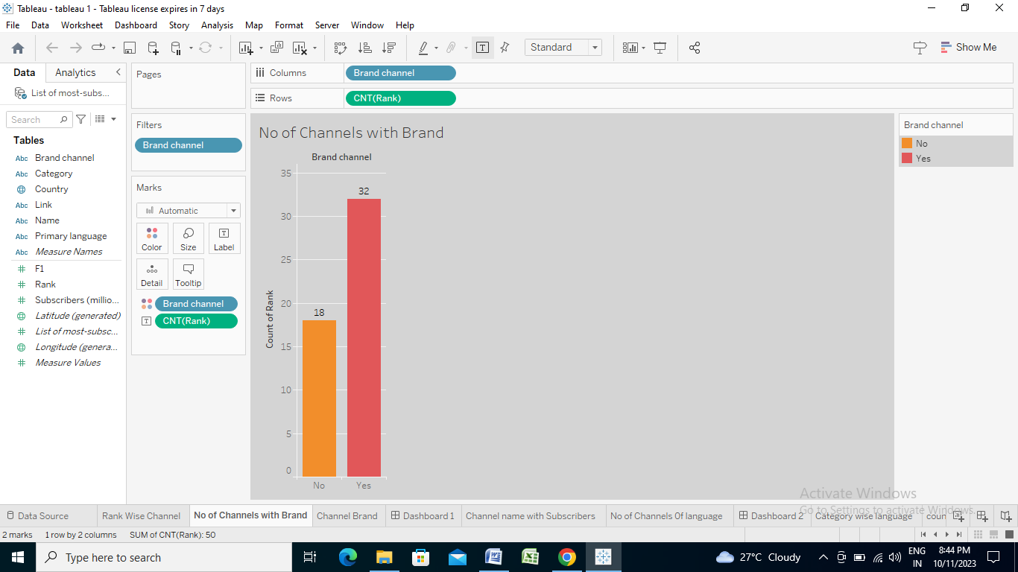

**Channel Brand:-**

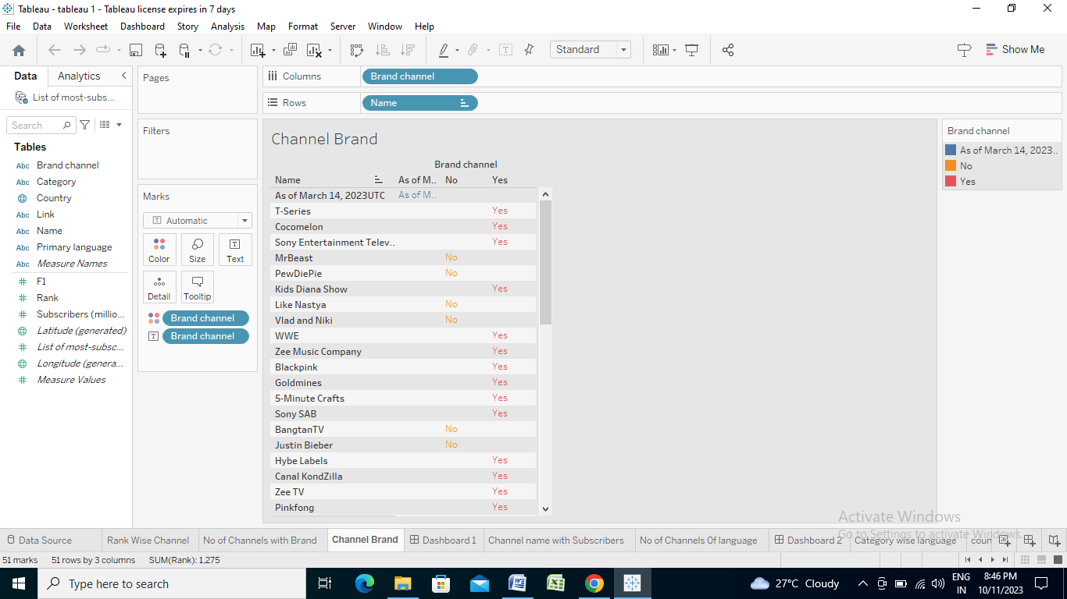

**Channel name with subscribers:-**

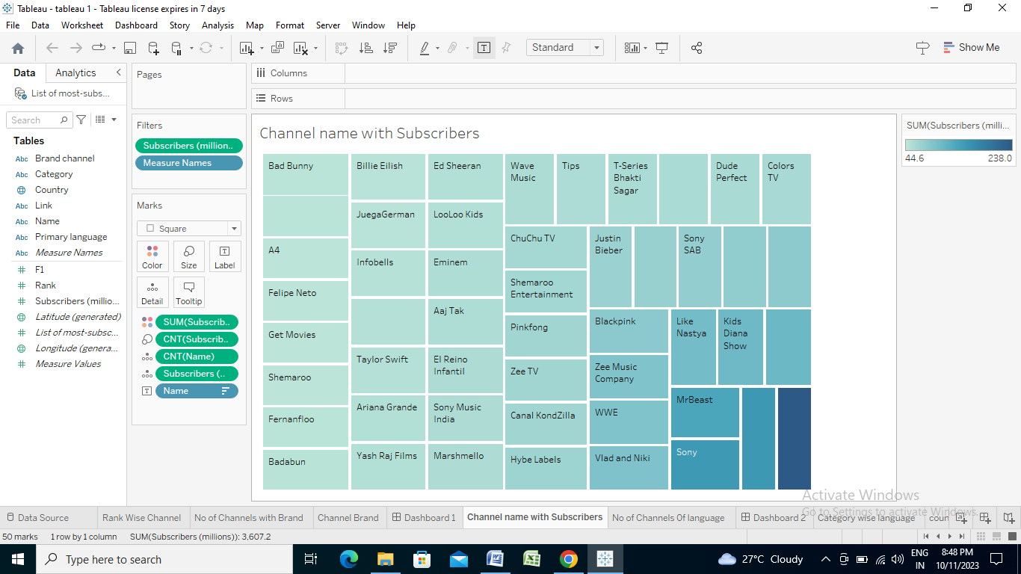

**No of channels for particular language:-**

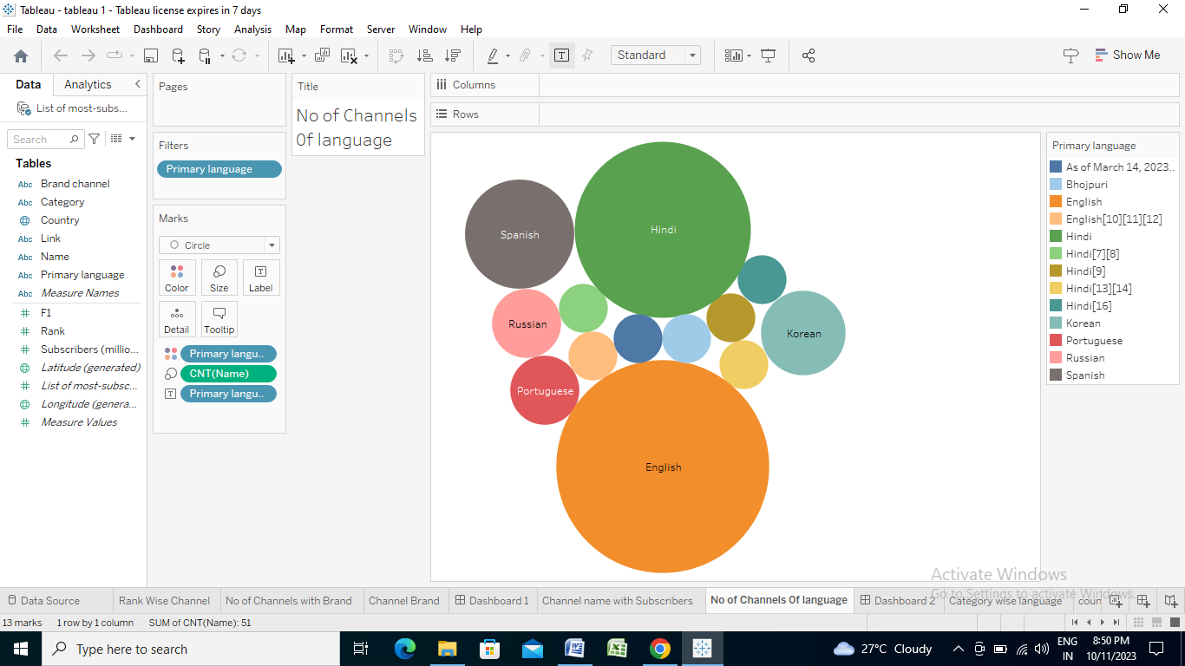

**Country wise Language :**

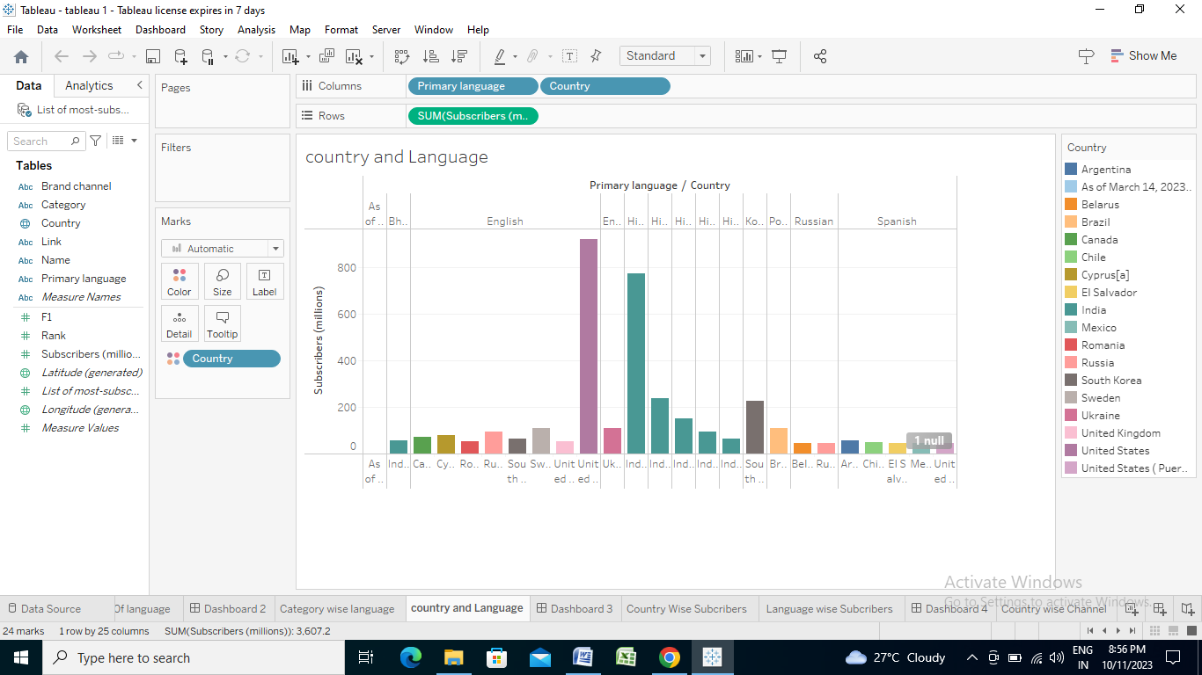

**Country wise subscribers:**

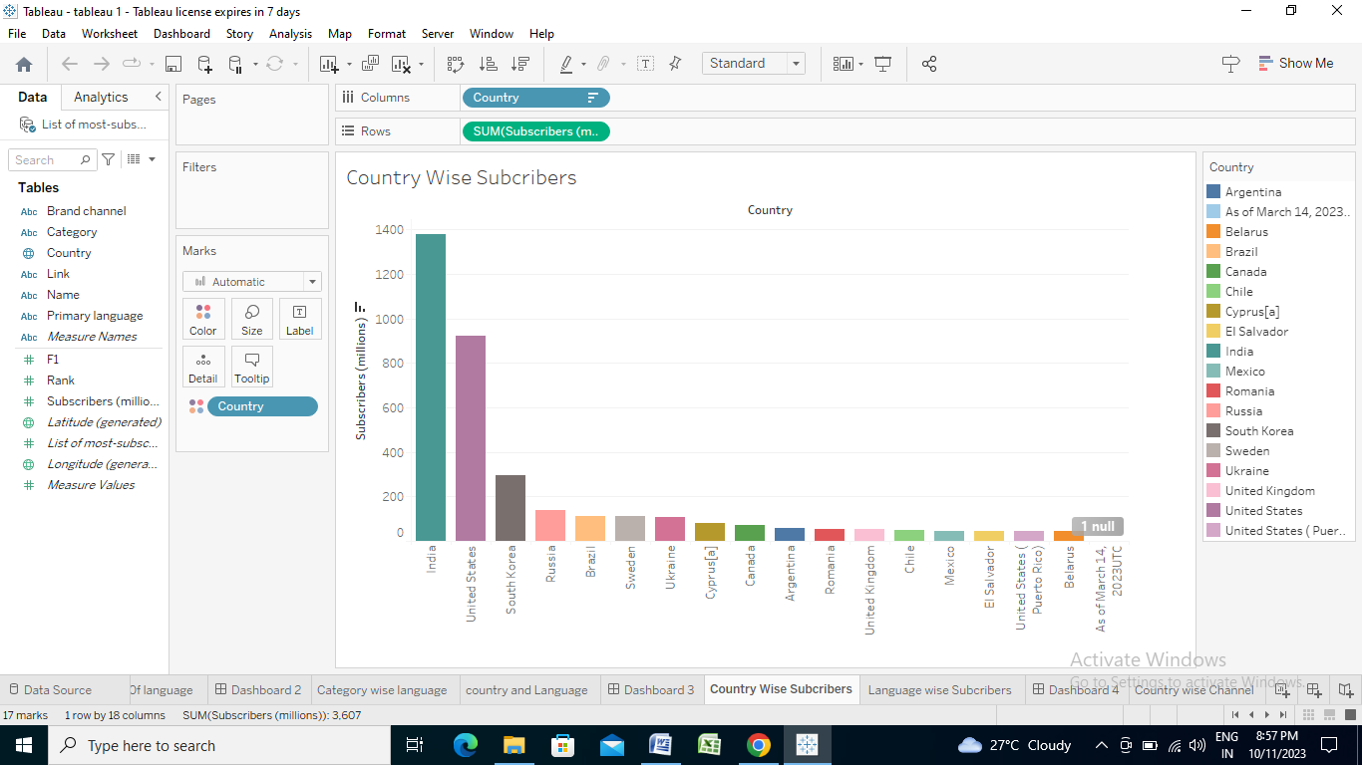

**Country wise Channel:**

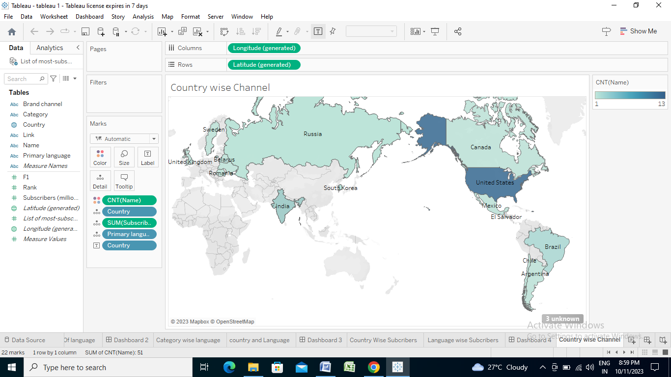

Dashboard:-

A dashboard is a graphical user interface (GUI) that displays information and data in an organized, easy-to-read format. Dashboards are often used to provide realtime monitoring and analysis of data, and are typically designed for a specific purpose or use case. Dashboards can be used in a variety of settings, such as business, finance, manufacturing, healthcare, and many other industries. They can be used to track key performance indicators (KPIs), monitor performance metrics, and display data in the form of charts, graphs, and tables.

***Responsive and Design of Dashboard:***

The responsiveness and design of a dashboard for Data-Driven insights on YouTube channels Analysis is crucial to ensure that the information is easily understandable and actionable. Key considerations for designing a responsive and effective dashboard include user-centered design, clear and concise information, interactivity, data-driven approach, accessibility, customization, and security. The goal is to create a dashboard that is user-friendly, interactive, and data-driven, providing actionable insights.

**Dashboard 1:**

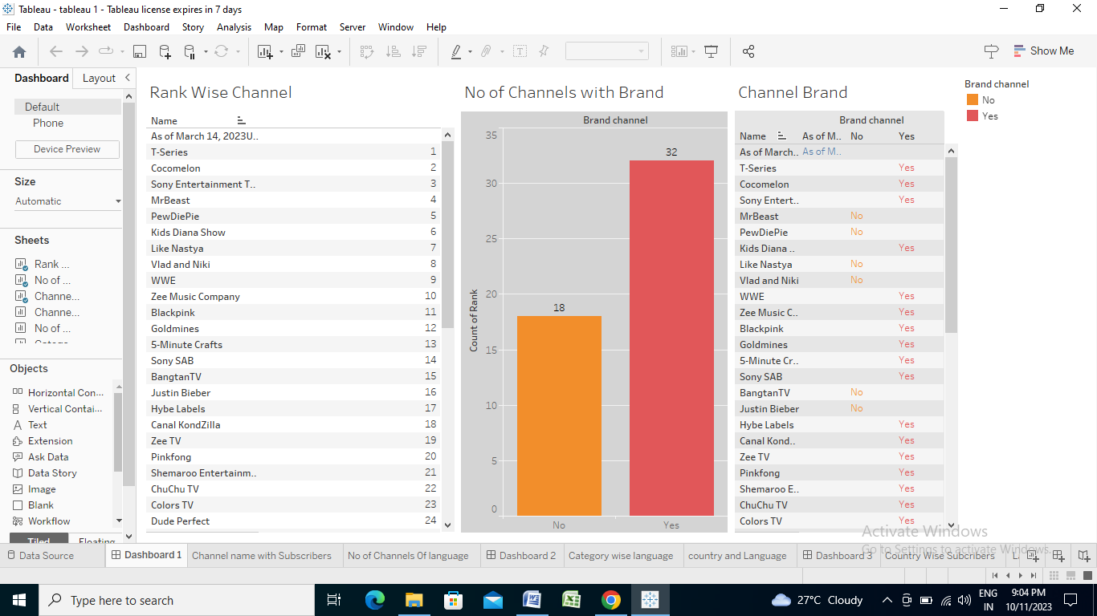

**Dashboard 2:**

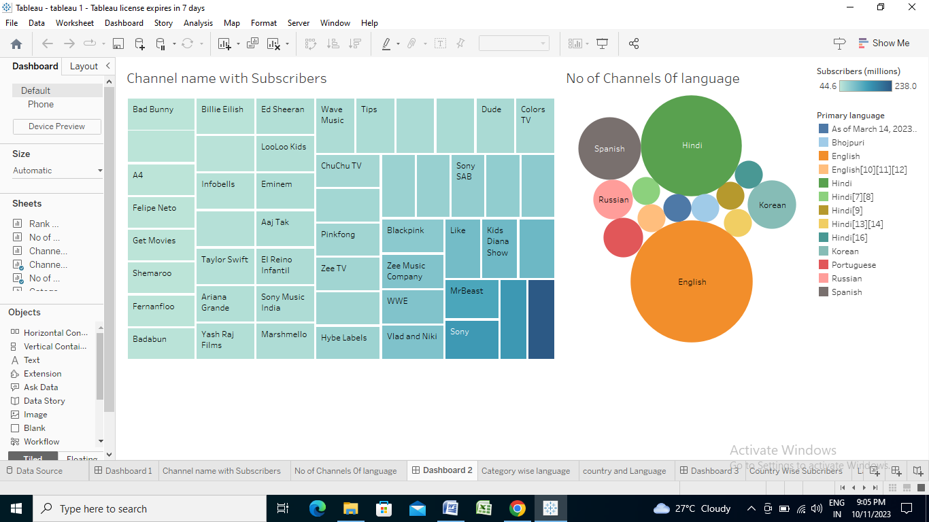

**Dashboard 3:**

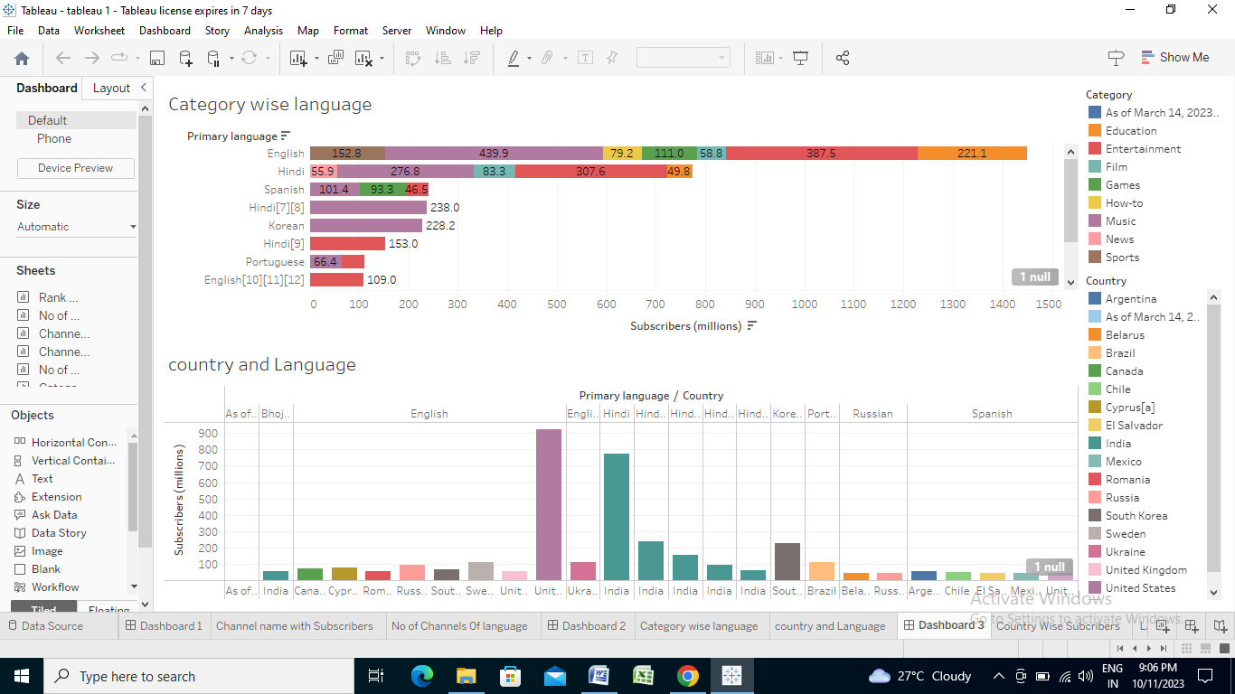

**Dashboard 4:**

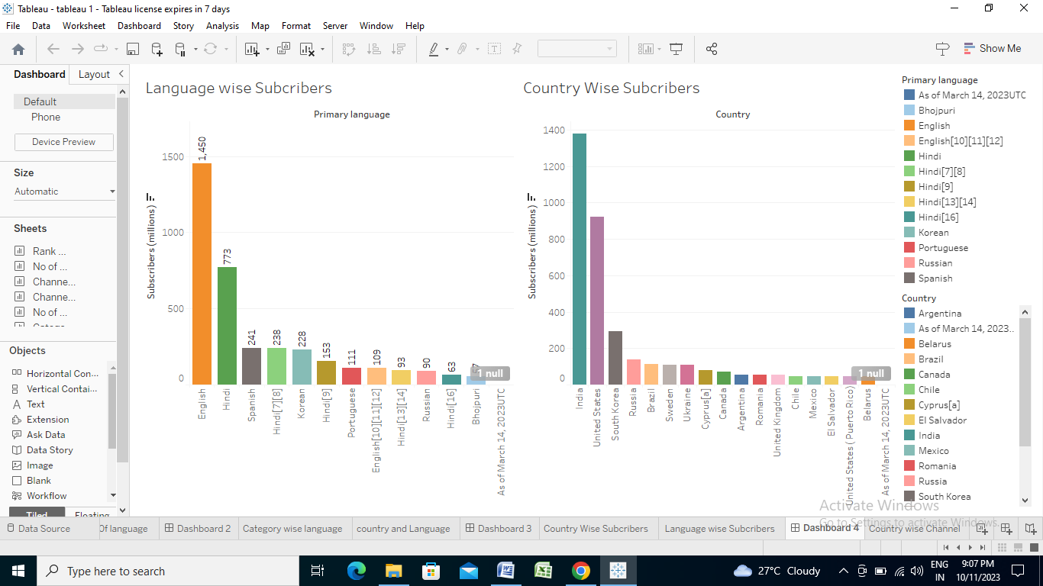

Story

A data story is a way of presenting data and analysis in a narrative format, with the goal of making the information more engaging and easier to understand. A data story typically includes a clear introduction that sets the stage and explains the context for the data, a body that presents the data and analysis in a logical and systematic way, and a conclusion that summarizes the key findings and highlights their implications. Data stories can be told using a variety of mediums, such as reports, presentations, interactive visualizations, and videos.

***No of Scenes of Story:-***

The number of scenes in a storyboard for Data-Driven insights on YouTube channels Analysis will depend on the complexity of the analysis and the specific insights that are trying to be conveyed. A storyboard is a visual representation of the data analysis process and it breaks down the analysis into a series of steps or scenes.

**Story 1:**

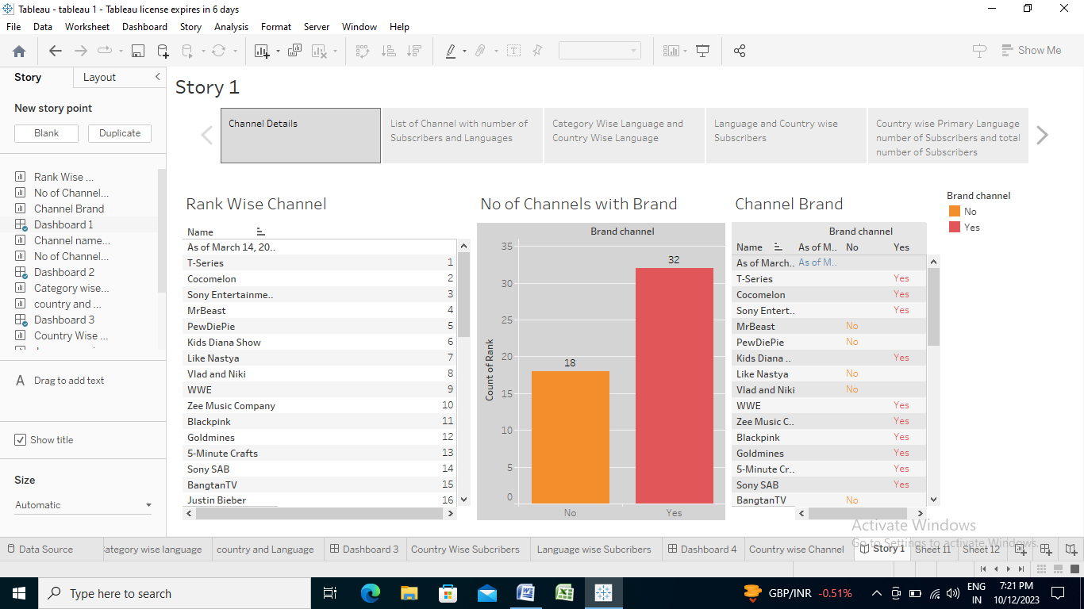

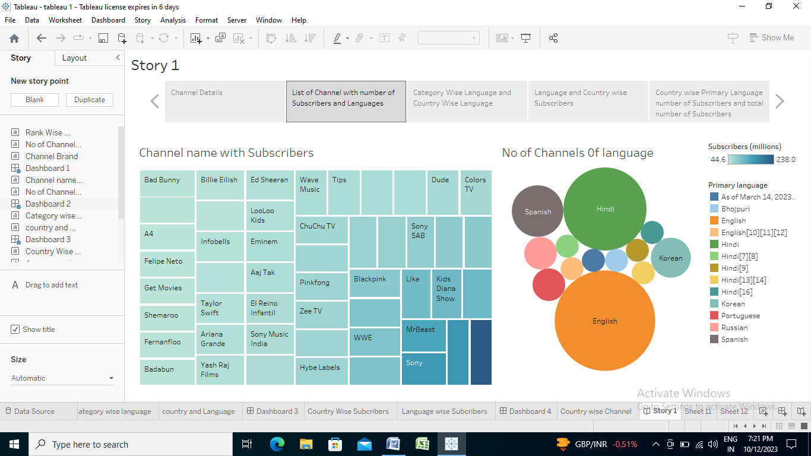

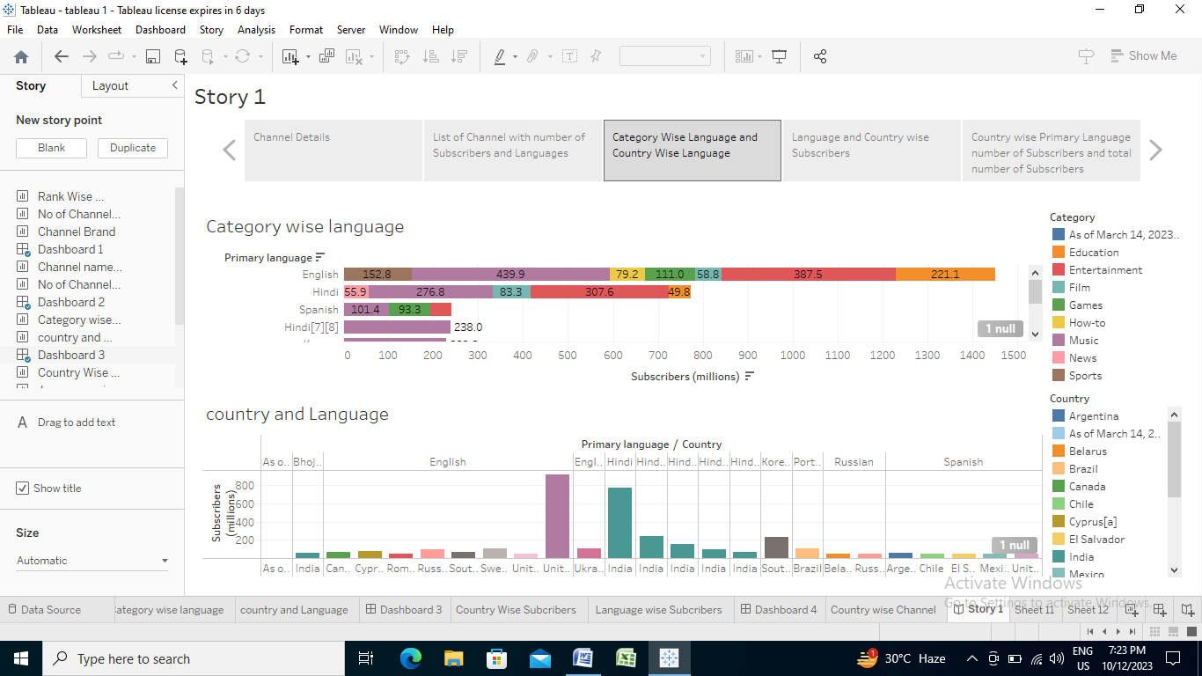

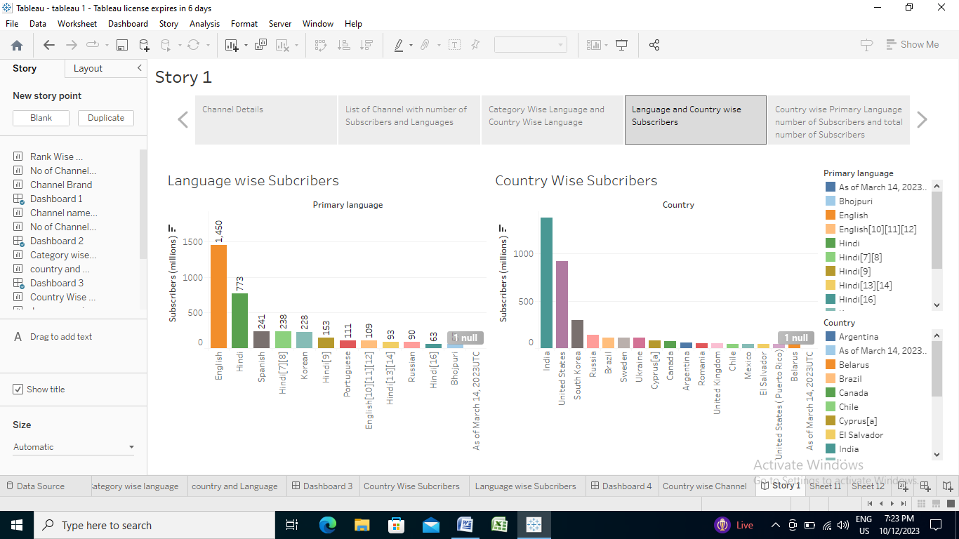

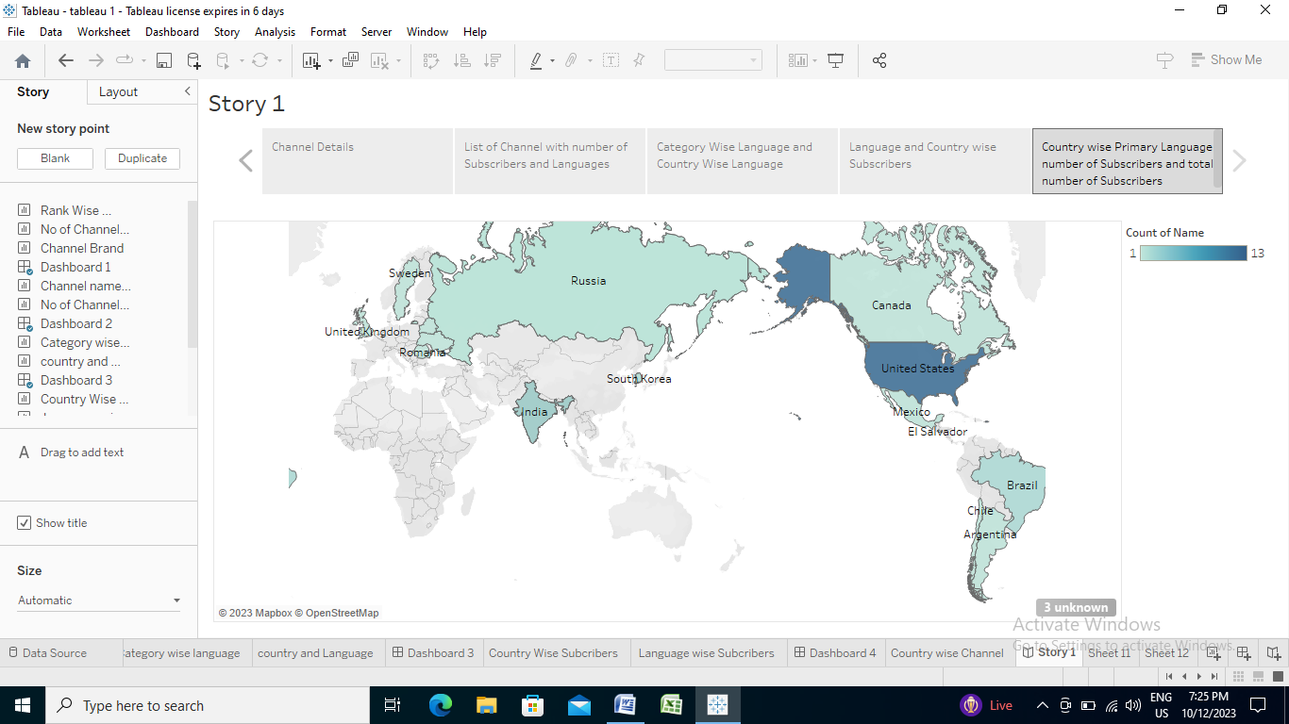

Performance Testing

***Utilization of Filters:-***

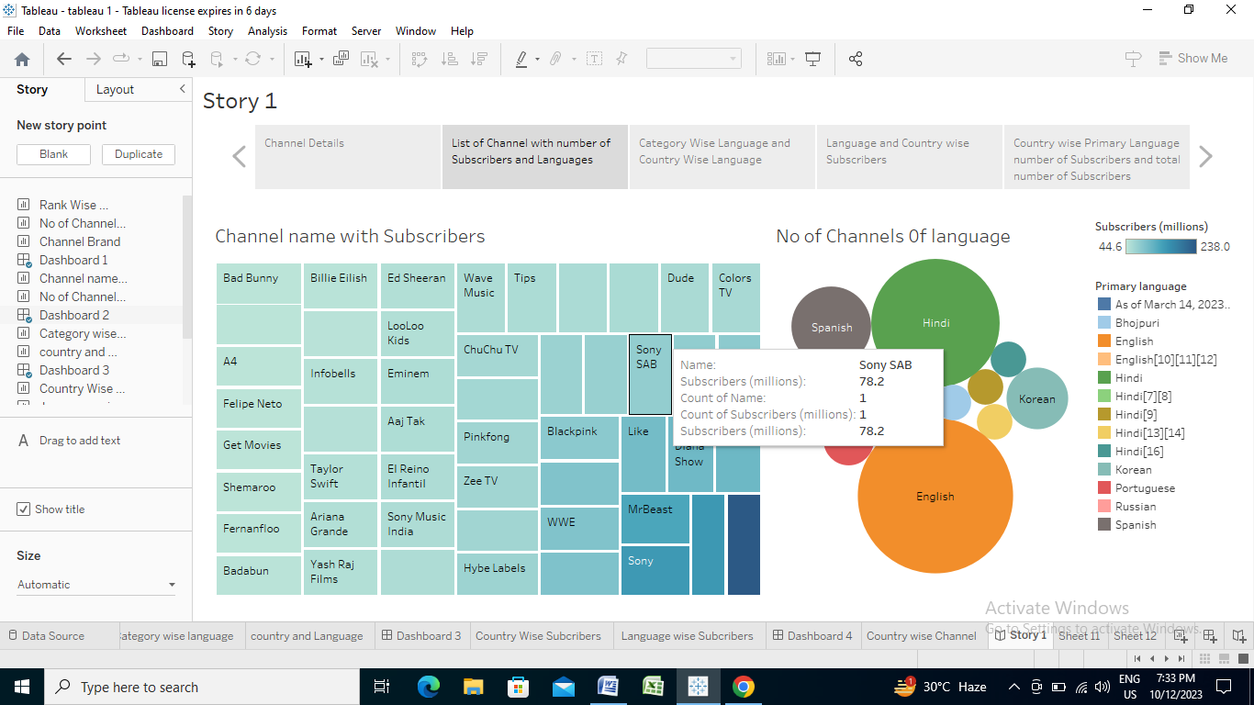

***No of Visualizations/ Graphs:-***

1. Table shows Rank wish channel.

2. Bar graph shows the number of channels with Brand.

3. Table shows Brand.

4. Heatmap shows channel name with subscribers.

5. Circle shows a number of channels with a particular language.

6. Bar graph shows category wise language.

7. Bar graph shows the Country with its primary language and number of subscribers.

8. Bar graph shows language wise subscribers.

9. World map showing Country wise channel.

Publishing

Publishing helps us to track and monitor key performance metrics, to communicate results and progress. help a publisher stay informed, make better decisions, and communicate their performance to others.

**Publishing dashboard and reports to tableau public :-**

**1**. Go to Dashboard/story, click on share button on the top ribbon

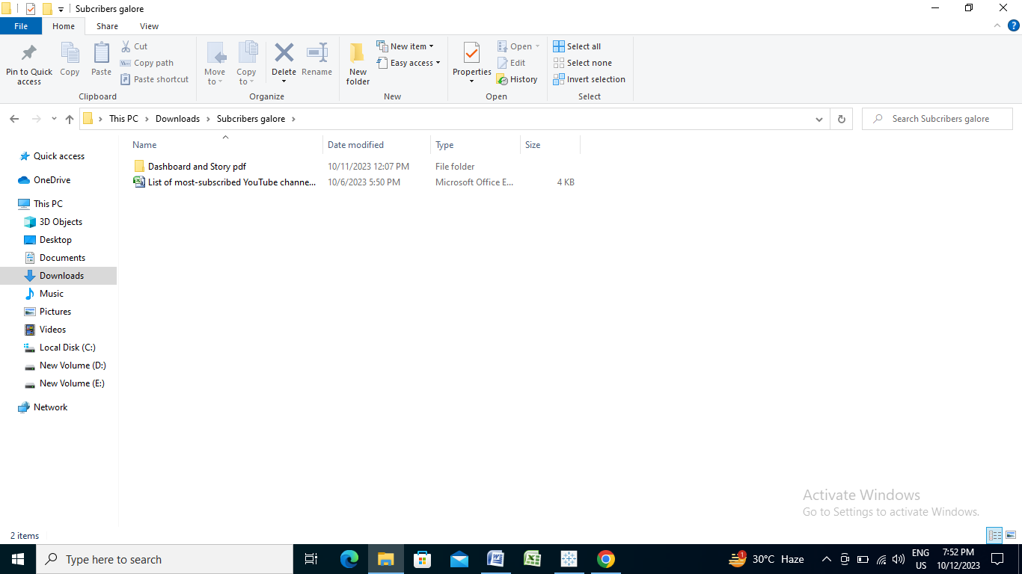

**The tableau server will displayed.**

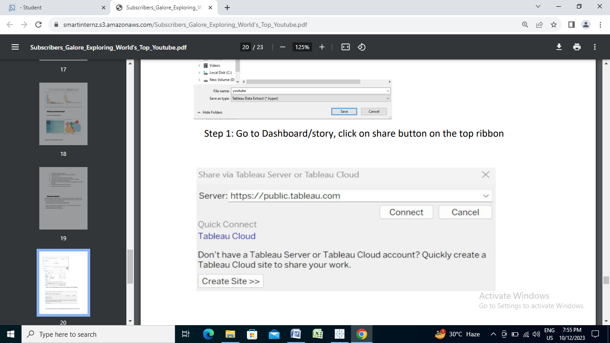

**Sign in the tableau public website:**

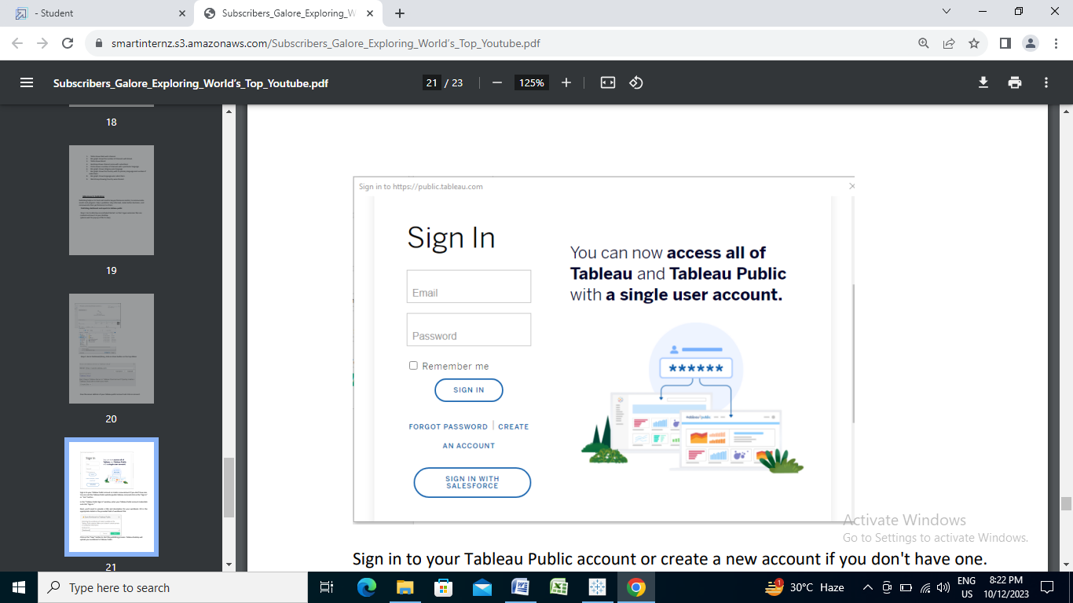

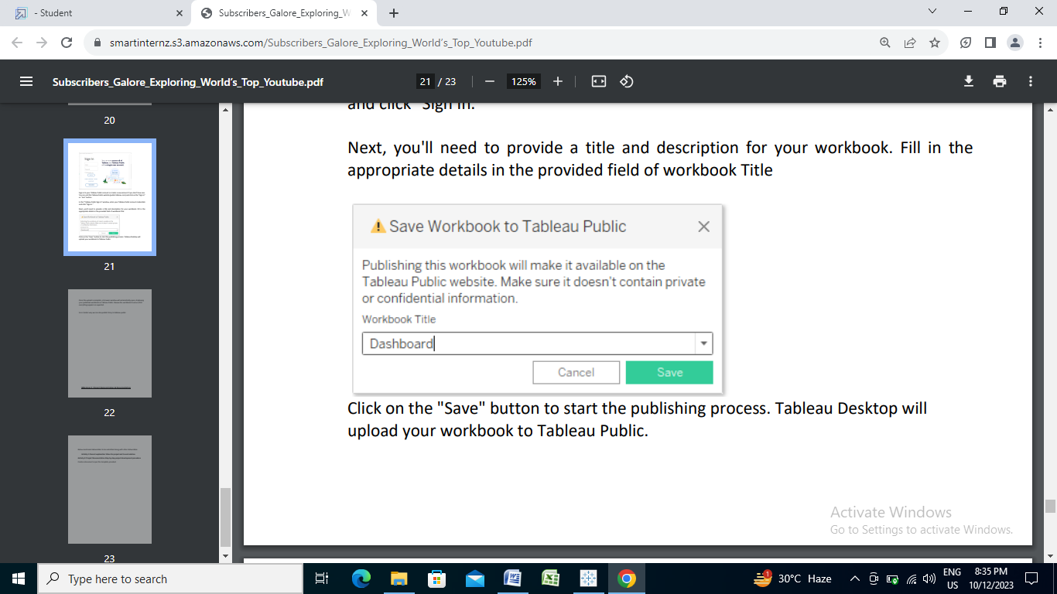 Once the upload is complete, a browser window will automatically open, displaying your published workbook on Tableau Public. Review the workbook to ensure that everything appears as expected. So in Similar way we can also publish Story to tableau public.

Project Demonstration & Documentation

Below mentioned deliverables to be submitted along with other deliverables.

1. Record explanation Video for project end to end solution.
2. Project Documentation-Step by step project development procedure.

A document as per the template.

# .....THAT’S ALL ABOUT MY PROJECT…..